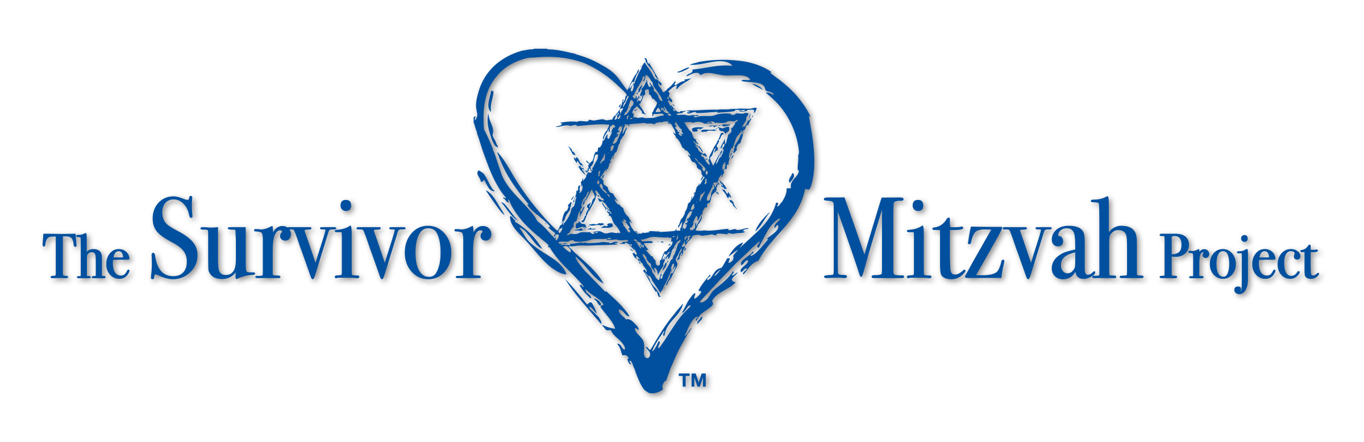

{Your Name Here}

For my Bar Mitzvah I have decided to help the award-winning Survivor Mitzvah Project
provide lifesaving aid to the last survivors of the Holocaust in Eastern Europe
who are ill, impoverished, isolated and are in desperate need of food, medicine, heat, and shelter. Many live in horrific conditions, without family or caregivers. Together we can change that!

In honor of the 6 million who perished, I am helping those that survived.

Please join with me in helping these Holocaust survivors by donating to
The Survivor Mitzvah Project in honor of my Bar Mitzvah.
Please make sure to reference my name with your heartfelt donation.

For more information or to donate online, visit www.survivormitzvah.org
To donate by check please make checks payable to “SMP”
and send to:
The Survivor Mitzvah Project
2658 Griffith Park Blvd. , #299
Los Angeles, CA 90039

The Survivor Mitzvah Project is a 501c3 non-profit organization.
All donations are tax deductible.
100% of every dollar donated goes directly into the hands of a Holocaust Survivor in need.

Your donations help Holocaust survivors in Belarus, Estonia, Latvia, Lithuania, Moldova, Transnistria, and war-torn Ukraine.

Thank you for your kindness and compassion!

Who Saves a Life, Saves the World Entire

800-805-6160

CNN HERO AWARD • ANTI-DEFAMATION LEAGUE (ADL) AWARD
MENSCH INTERNATIONAL FOUNDATION AWARD • KCET LOCAL HERO AWARD

The Survivor Mitzvah Project • 2658 Griffith Park Blvd., Ste. #299 • Los Angeles, California • 90039

